Parallel Programming Assignment Report Template

Students Information
Student Name: Samer saad reyad / Mena magdy / Abanoub hashmet / Bassem adel

Problem Information
Problem Title: Pi Calculation with Race Condition
Lecture Number: 2

Problem Description
Unintended sharing of data causes race conditions
when the program’s changes scheduled differently
solve
Use synchronization to protect data conflicts
Calculate PI using numerical integration with multiple threads.
π=∫ 4.0 / (1.0 + x * x) ​dx

Parallelization Approach

1- The loop is parallelized using OpenMP (multi-threading )

Solution Explanation
- All threads update the shared variable pi simultaneously

Source Code
- 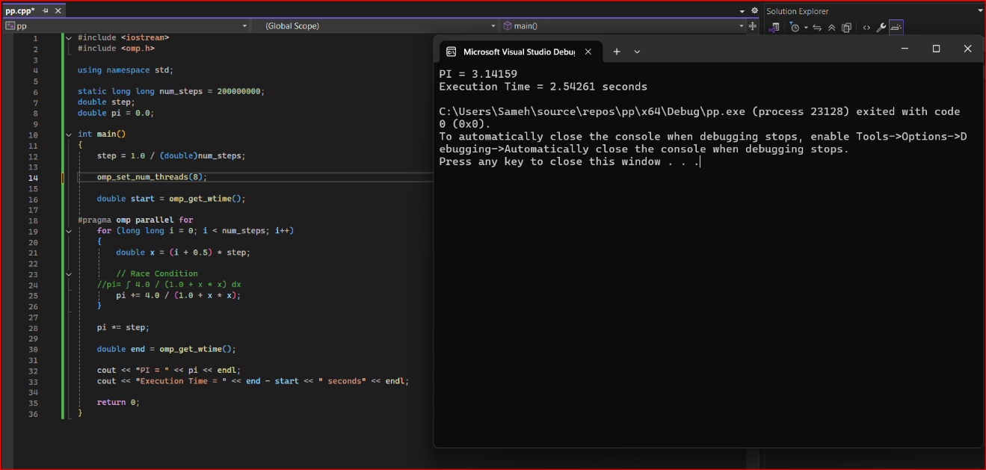

Execution Results

PI = 3.141592653589

Execution Time =like 2.54 seconds because the number of threads increase
Conclusion
The parallel implementation significantly reduces execution time. Race conditions are eliminated.
To solve Use synchronization to protect data conflicts (from Lecture 2 )

